**Logo of wbsiste**

**WALMART**

An E-Commerce Shopping WEBSITE



University of Engineering and Technology  
Lahore 2022

**ABSTRACT:**

It is an online busisness and trading website through which

TABLE OF CONTENTS:

ABSTRACT………………………………………………………………………..

1 INTRODUCTION………………………………………………………………..

2 PROBLEM STATEMENT………………………………………………………

3 OBJECTIVE……………………………………………………………………..

4 RELATED WORK………………………………………………………………

5 PROPOSED METHODOLOGY………………………………………………

6 GAINT CHART………………………………………………………………….

7 WIREFTAME……………………………………………………………………

8 FUNTIONAL REQUIREMENTS………………………………………………

9 NON-FUNCTIONAL REQUIREMENTS……………………………………..

.Figure 1

.Figure 1

.Figure 1

.Figure 1

.Figure 1

.Figure 1

.Figure 1

.Figure 1

.Figure 1

.Figure 1

.Figure 1

.Figure 1

.Figure 1

1 INTRODUCTION

It is an American multinational retail corporation that operates a chain of hypermarkets (also called supercenters), discount department stores, and grocery stores from the United States . It is a business model that allows companies and individuals to buy and sell goods and services or transmitting of funds or data , over an electronic network , primarily the internet .

It was launched in 1962 by retailer Sam Walton.in the first company wa based on simple vision ; pass the savings from buying in bulk on to customer and earn the profit through volume .by controlling payroll costs fighting unions and hiring as little man as possible ,Wal-Mart kept growing steadily. It operates in three segments: the Walmart US segment ,WalMart International segment with stores in 26 countries and Wal Mart International accounted.

It allows us to offer products and services to people anywhere in the world. It provides job opportunities and reduce the gap between job seekers and job givers in the society. It provides safe , affordable food and other products to people around the world .it enhances economic opportunity ,environmental and social sustainability ,and local communities creates value for business and for society.

After launching a set of ambitious sustainability goals , including zero emission across its global operation by 2040,in September 2020,Walmart has added number of new commitments , expanding scope for its goal to source 100% more sustainable cotton and 50% recycled polyester.in short, it will becoming a “regenerative company”-one that places nature and humanity at the centers of its business and works to restore , renew, replenish and preserve the planet.

2 PROBLEM STATEMENT

3 OBJECTIVE

The main objective of Walmart is focused on improving the cost and convenience of health care and providing everything busy families and caregivers need to simply live healthier. This includes our pharmacists, who can answer medication related questions, help with prescriptions and provide immunizations. The organizational mission is the following:

“**helping people around the world save money and live better – anytime and anywhere – in retail stores and through eCommerce”**

. Walmart’s vision statement is “making every day easier for busy families” . The long-term objective of the company is expressed in its mission and vision. Walmart aims to sustain a low-priced strategy to serve busy families and save money for them .

4 RELATED WORK

Walmart is the world’s biggest company in terms of revenue. So, obviously, Walmart is extremely successful. Many companies like the Walmart doing very well job. **which offer incredibly low prices and a wide variety of household goods and grocery items. Walmart makes annually the most money, but some of the competitors come close. Kroger** is one of the biggest Walmart competitors, with over 3,000 nationwide locations. Like Walmart, the company sells grocery items and has a pharmacy located in almost every store.

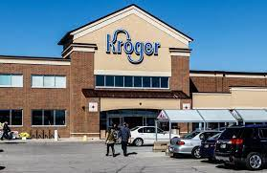

**Costco** is a wholesale membership-only retail store that operates over 804 warehouses worldwide, including 558 in the United States, and offers low prices but in bulk supply.

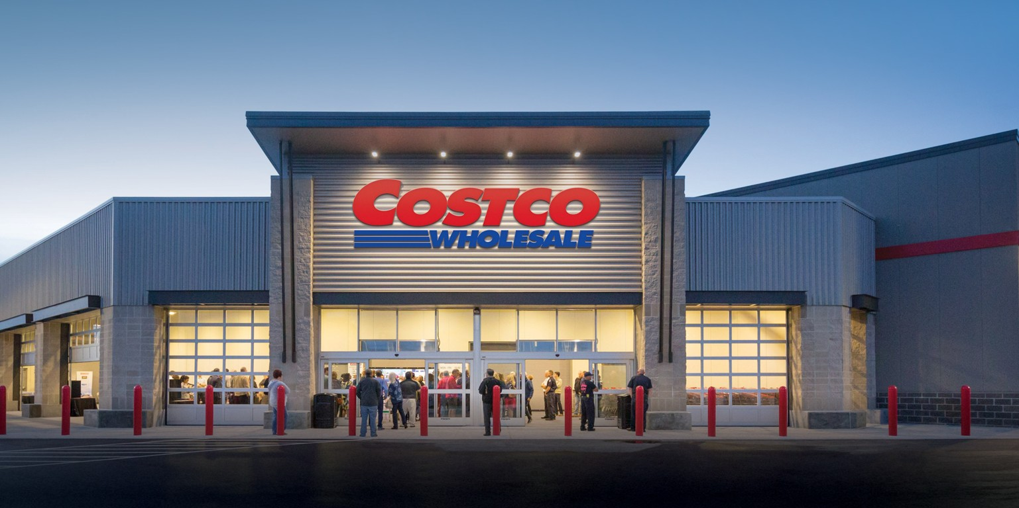

**Amazon** is an e-commerce website that has grown substantially in the last decade to become one of the biggest retailers in the world. The prices are often lower at Amazon than brick-and-mortar stores like Walmart.

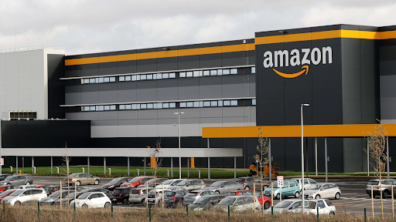

**Target** is one of the main competitors of Walmart due to it being very similar in size and layout to Walmart, and Target offers a lot of the same types of products as Walmart.

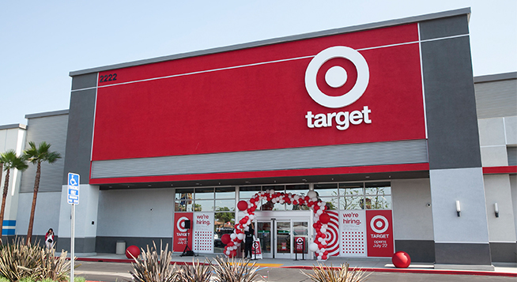

Walmart has a lot of competitors both in the United States and around the world. But, Kroger, Target, Amazon, and Costco are the biggest competitors of Walmart . Furthermore, these stores offer a variety of items just like Walmart, including groceries, electronics, household goods, and clothing items . Stores like Costco, Kroger, and Target offer goods at a low price, making it more of a competition to Walmart, which is known for incredibly low prices throughout the store.

**4 WIREFRAMES**

**5 Requirements**

**Non-functional requirements**

• **Security:**

Our system must be secure by keeping the credentials and private information of the users secure through two step verification and user authentication. Our system must be encrypted so that no one except the admin could access it.

• **Ease of use:**

1. All the requirements shall be according to user.
2. Menu items must have names that are self-explanatory.
3. Place holders must have available for the user.
4. The form provided to the user shall be easy to fill as only the necessary and basic information must be asked.

• **Availability:**

Our system must be must be available 24/7 by ensuring internet availability and other essentials.

• **Maintainability:**

Our system must be regularly maintained and modified to fix the bugs and issues by adding new features and functions to the interface. If any error occurs, system must be able to show the error to admin so that it can be fixed.

• **Scalability:**

Our system must be capable of supporting the changing requirements whether that’s in the form of new customers or a large form of data.

• **Responsiveness:**

1. Our system must response within 3 seconds to any of the user’s request.
2. Form must be shown to user within 2 seconds.
3. Submitted form must be received by admin within 5 seconds.
4. Product must be sent to cart in 1 second.
5. User must receive confirmation email within half an hour.

• **Compatibility:**

Our system must be compatible with all the devices i.e., computers, mobile phones, laptops etc.

* **Performance**

Our system